***Steps to add Home Address to Smart Source (SAP Ariba)***

1. Click on Guided Buying [link](http://w3.td.com/td/intranet/cs/ssg/overview/!ut/p/z1/04_Sj9CPykssy0xPLMnMz0vMAfIjo8zi_YxMHA3dTQy8LTx8zA0cQ4KdTc1DTYzcjUz0w8EKDAxMg029nQ09HQ38jZxCTLwsLQ0gQD-KOP3YgSOR-vEoiMJvfLh-FF4rvM2hCvB5kZAlBbmhoREGmZ4AvceqjQ!!/dz/d5/L2dBISEvZ0FBIS9nQSEh/)
2. Click on **Get Started** under TD Smart Source
3. Click on **Support & Policies**
4. Click on **TD Business Process Forms**
5. Click on **SSG Support Forms**
6. Click on **Adhoc Address Add Form**

* Once form is submitted SSG Support will get the ticket to add the home address to Smart Source.
* Support will inform the submitter once the home address is added to the system.
* Once home address is added to the system then end user can go ahead and create the requisition using their home address as **Ship to** address

***How to access ROVA***

Click on [TD Smart source](http://td-c1.procurement.ariba.com/?guidedbuyredirect=true) > Click on **Office Products & Services** > Click on the arrow to navigate to the ROVA punchout. Alternatively, you can type the name of the punch out on the "**Find Good and Services**" field to navigate directly to the ROVA punchout.

After the item has been selected from the punchout > Click on **Proceed to Checkout** > **Checkout** > System will take the end user back to the Smart Source > Click on **Checkout** again

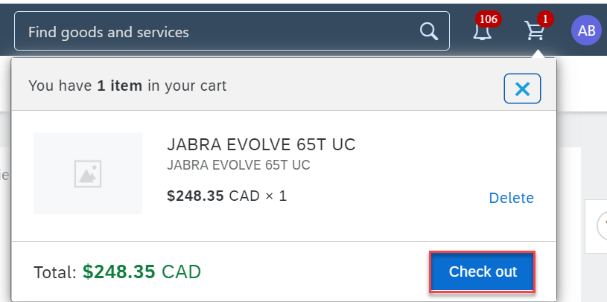

***How to update "Ship to address" on the requisition – (Line level)***

* Scroll down and click on the arrow next to the **items**

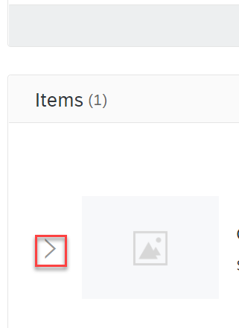

* Click on **Shipping**

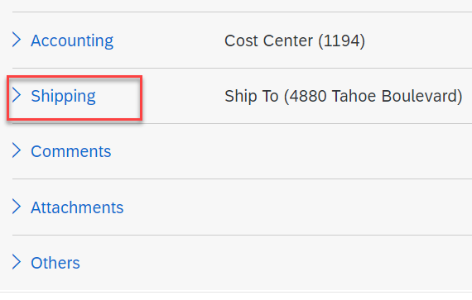

* Click on the **arrow** next to **Ship To** > **Browse all**

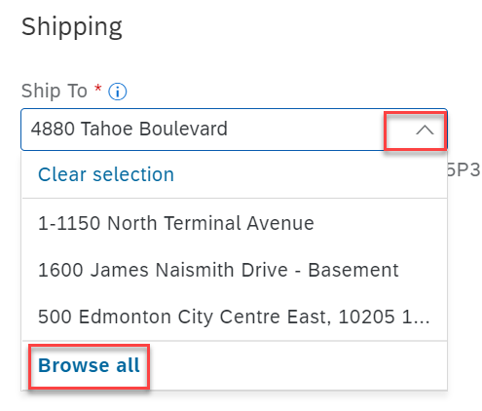

* Search can be done with **Street** or **name**

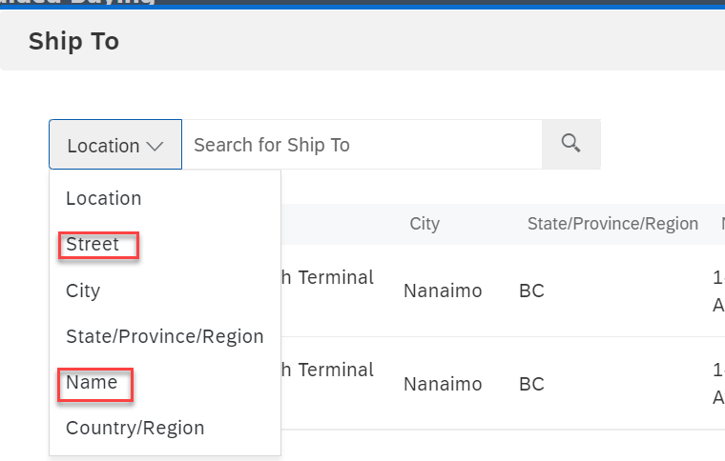

* Click on **Choose >** Click on **Done**

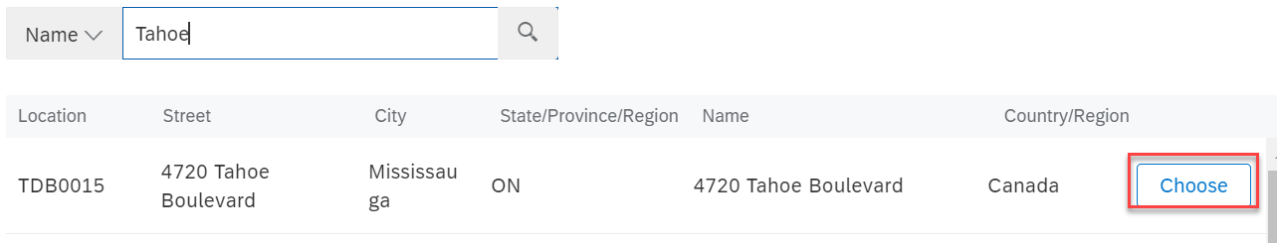

Please Note – Postal code is not visible on this screen but once the address is selected Postal code will be visible on the original screen

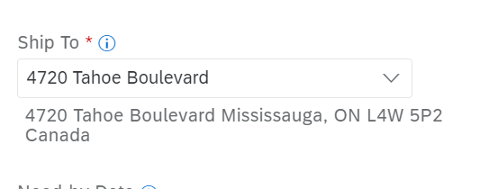

Update "**Deliver To**" field to show name of the person who will be receiving the package once shipped.

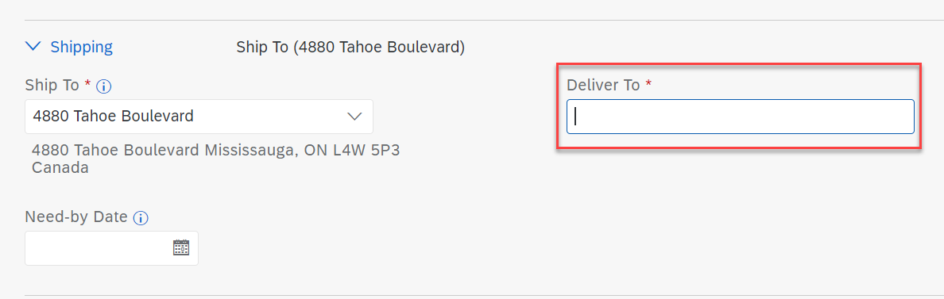

***How to update "Cost Centre" on the requisition – (Line Level)***

* Scroll down and click on the arrow next to the **items**



* Click on **Accounting**

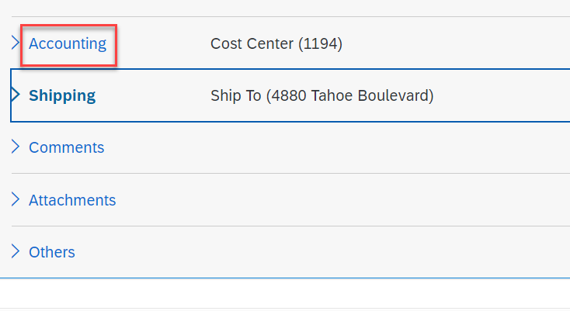

* Click on the arrow next to Cost Center > Click on **Browse all**

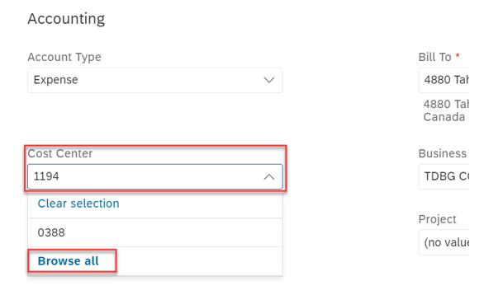

* Search for the cost centre by typing the CC# > Click on **Choose >** Click on **Done**

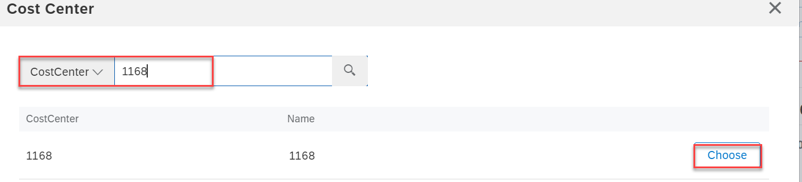

**Please note** – Users with Canadian purchasing Unit can search for ONLY Canadian Cost Centres; Users with US Purchasing Unit can search for ONLY US Cost Centres and Users with NY purchasing units can search for only TDS cost Centres. Steps to request for additional purchasing unit access are same as request for addition of home addresses. Instead of "Adhoc Address Add Form" select "**Access to Additional Purchasing Unit**" form.